(Approx. 2042 words)

Software Review - Collectorz.com Book Collector Pro
By Tanya and Mark Mattson, Computer Users of Erie, PA
August 2011 issue, Horizons
www.cuerie.com
cuerie1 (at) verizon.net

I am going to start off with an Excellent rating for not only the Book Collector software, but for the content and design of the Collectorz.com site all together.

I had searched for (and found) a book cataloging software application that would do what I needed. Loved it, but it was obsolete and no longer being supported or developed by the author. So I started on the hunt for a new one.

I came across the Colletorz.com Book Collector. It had what I wanted and so much more. I was looking for an easy way to catalog not only the CUE library but ours at home as well. And with simply typing in the IBSN or scanning the bar code, it is good to go. Yes you do need a barcode scanner to make that feature work, but it is an extra way of inputting your books...NOT the only way.

First I want to give you a screen shot from their site –

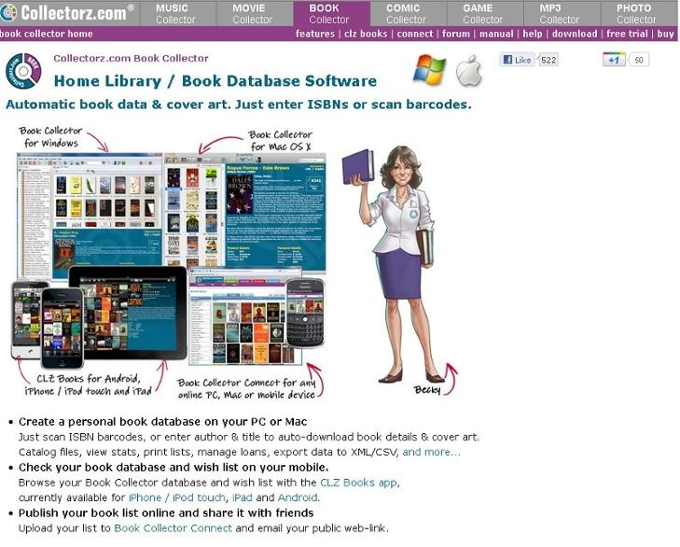
Book Collector page on Collectorz.com website

The first thing one notices is that they offer so much more. Music, movie, book, comic, game, mp3, and photo collector applications. All their programs are Windows friendly, and several - Music, Movie, Book and Comic Collector - are also Mac compatible. This is always a big plus for me; I get annoyed at the software companies that cater to one system or the other. Just adds so much confusion. And since I know our members have PC and Mac systems all around, it is great to be able to do a software review that can benefit everyone.

So how does it work? Well there is a free trial, and once downloaded and installed it is easy to begin. You can just type (or scan) the ISBNs of your books. Or you can enter the author and title – either way it will auto-download book details and the cover art, and load all this information into the program’s database fields for you.

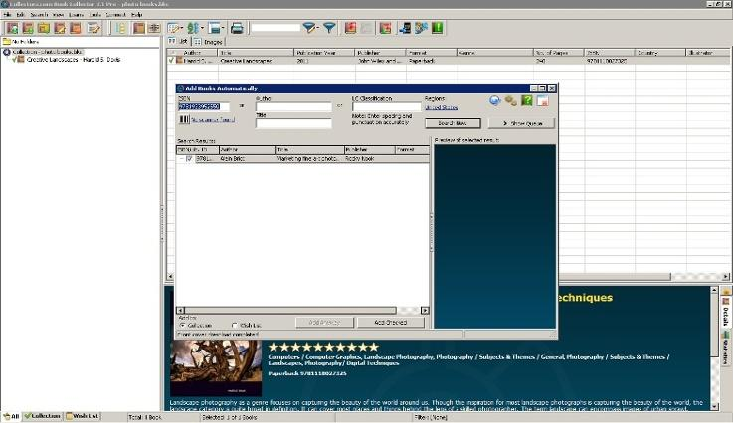
Screen capture of ISBN entry page, adding new book

This is not just a catalog of files. Once entered you can sort and search, you can browse the database (your book inventory – or collection) by Author, Title, Publisher, etc. Grouping books by Genres or Author into folders is another handy feature built in to the program.

Export your data in various formats, including to you iPad, iPhone, and Android devices. Won't be at the book store rummaging around for that scrap of paper that in some weird shorthand I made up to tell me what I have and don't have in my library. Printing is also an option.

What I found to be one of the nicest features was their trial. Not a 15 day limit, but 100 book entries. Try it out for a spin, and see that it is a win. Be aware, however, that the TRIAL version is actually the PRO version...all features are available for you to try out. If you purchase only the Standard edition license, those features listed as being in the PRO version will no longer function. Please remember this when purchasing.

Catalog customization options are available in either Edition. One can edit a books’ details. There is a collection status field; is a title on your wish-list, for sale, already owned, or out on loan. You can flag any number of titles with such custom information tags.

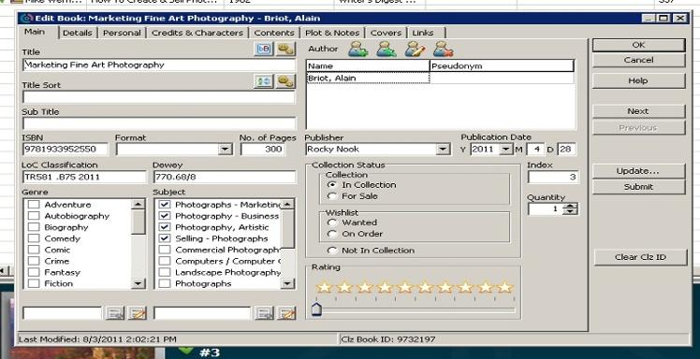
Book data editing window

Installation and System Requirements

Book Collector is available direct from the publisher’s website at www.collectorz.com. Click on the Book Collector tab at the top to go to the proper page. There you will find the link to download a trial version, or to go to their online store to purchase a license.

The program is delivered via direct download. You are emailed a link to the download location, where you save the file to your system. It is a small download, only 5.5 MB in size...so it will download fairly quickly.

There is also the option to have it delivered via physical shipment of a CD for an extra $9.95. If you wish the CD to be shipped, be sure to select this option during purchase.
The disc comes in a DVD-style case, with the program logo on the cover.

For those downloading the program, the file is a self-extractor; double-click on it to start the installation procedure. Installation is simple and straight-forward; select the default options, and you’re ready to go in a matter of about a minute.

As this review was based on a download version, we can only assume that the CD will auto-run when inserted in your computer drive, starting the installer automatically. However, we could not test this out. But as that is the way modern programs are set up, it is likely to be the case.

The program appears to use very little of your system resources. In fact, I couldn’t find any listed system requirements on their website, other than the operating systems supported. For Windows, it needs Windows 2000, XP, Vista, or Windows 7. For Mac users, you need at least OS-X v10.4 or higher, up to and including Lion.

Please note that you will also need an active Internet connection, to enable auto-downloading of your book details and cover images.

There are several localized translations for the Windows platform besides English, but the Mac version is English-only. Also, when you go to the store page to purchase, if you are buying a Mac license, be sure to use the link at the top right of the store page to go to the Mac order area...otherwise, you’ll be getting a Windows license.

Book Collector can be purchased in two versions: a Standard Edition for $29.95, and a Pro Edition for larger collections priced at $49.95. Remember that the trial version is actually the full Pro version. Many Pro-only features will NOT be available if you only purchase the Standard edition.

As indicated before, there are a ton of options available for you to work with your book data. You can sort your database by any field, do custom searches, and more. You even have the ability to save custom searches as presets for future use - saving you time in recreating them later.

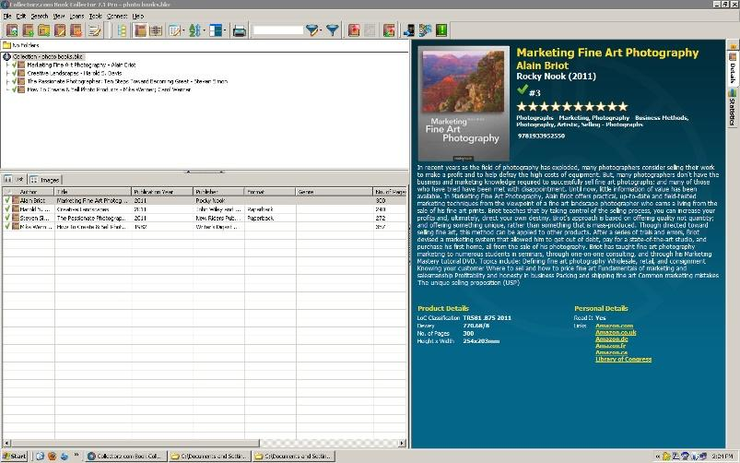
Alternate main window layout

The default view of the program can be changed, either to one of several available presets, or you can go all out and create custom templates, to change the look of the interface to fit your taste.

One feature that is available is the ability to use a barcode scanner to input the ISBN numbers on your books. This will vastly speed up the process of cataloging your collection, especially those with hundreds or thousands of titles.

Collectorz.com sells several barcode scanners that they’ve tested to work with the software. They are listed on the store page for your convenience. One such unit is the Cuecat scanner. It lists for $19.95 in their store. BUT, if you’re like me and like to haunt Radio Shack stores, about 10 years ago or so they gave away these units with their yearly catalog. I still have mine, and will be hooking it up to try out in the near future. The only thing is, I think it’s an RS-232 model, and I’ll need an RS232-to-USB adapter to connect it to my system.
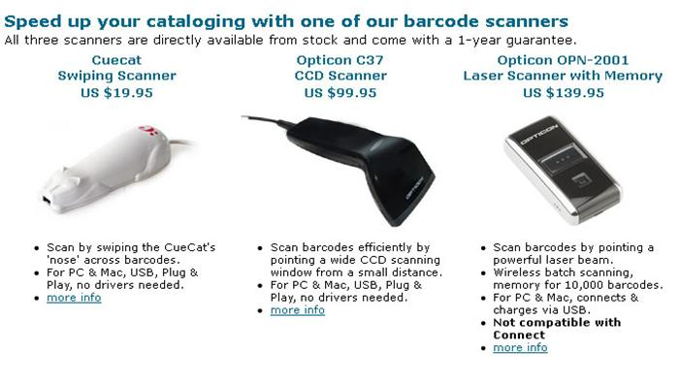
Barcode scanners available from Collectorz.com

Are you one that lets others borrow your books? Then this program will also benefit you. The PRO version also has a Lending system built-in, giving you the ability to track the titles you lend to friends and family. You can enter names, dates, and other information such as notes, to help ensure you get your treasured books back.

You even have options for printing and exporting lists of your collection, to such formats as HTML and XML. Allowing you to publish to your website for all to see. But exporting is only in the PRO version.

The only area that MAY bother you to some extent, is the way that the dimensions of the book are shown. As this is a European company that designed Book Collector, they use the metric system for measurements. Thus, the length and width are shown in millimeters, not inches. There also is no option available to switch it to the inch system we in the States use.

However, this really shouldn’t be a deal breaker for you when considering the program as a whole. It actually is more accurate, as some books published here use some weird measurements...I’ve seen books listed as 9.6” on a side. Measuring something like that on your inches ruler will give you fits. Metric measurements are more precise for this. If you really need inch measurements, be patient; the developer has indicated that an option to select inch measurements is on their To-Do list for a future revision, so it WILL be an available option at some point.

Currency fields use the OS default location to set the currency field to match your location. Thus, for US users, it uses the $ as we are all used to. If it shows something different, better check your system settings!

There is a LOT more that can be published here on this program. However, it would most likely fill up the rest of the available space doing so. If you want some really in-depth information and looks at Book Collector, be sure to go to the website and look at all related pages.

There is an online manual there, giving you details on all functions and features. Many topics also have short video tutorials or demos embedded in them, to give you a better grasp of a certain concept. A really well done and designed document. Unfortunately, there is no way it can be printed at this time...but it is always online, ready and waiting if you need it.

There is also a Help / FAQ page, with many standard questions and answers set forth. There are many there that you may not think of when first checking out the program...but the questions I was thinking of were there, and answered to my satisfaction (such as ‘What if my book doesn’t have an ISBN number?’).

It’s obvious that the majority of this review has concentrated on print books being cataloged. But never fear, if you’re moving to eBooks or audio books, they too can be added to the database, to ensure you have a complete listing of all your reading materials. Adding these types of media is as easy as scanning the folders they reside in on your hard drives. Once the basic catalog information is imported from the scan, you can use the Update function to retrieve the full information form the online Collectorz.com database.

If books are not the collection manager that is being looked for - Check out their site www.collectorz.com – tabs on the top will direct you to Music, Movie, Book, Comic, Game, Mp3 and Photo Collector applications.

This program is not just for “collections” which one associates with first editions and rare books, it is an inventory, a database, a cataloging system, that is easy and fun to use.
So check them out – we all know the holidays are right around the corner, this would make a nice gift for yourself, or someone that has a collection, be it books, games, or movies. And organization goes along way – to make less hectic lives. And less stress. (I hate it when I buy two, [and yes once, but only once three] of the same book or even movie).

For as simple as it is designed to use, this is an amazingly powerful piece of software. It already holds promise of organizing our home book collection, helping us avoid duplications of titles, and to plan which ones we’d like to add. For the price, it is a bargain. But it is worth a lot more just for the time and effort savings it brings to your life.

Two thumbs up from both of us.

Definitely a ‘Must-Have’.

